**Supplementary Requirements Release2**

1. **CN – Connectivity**

**Scope:**

* UC02.01 Ability to create and add a post.
* UC02.02 Create and add a comment to a post.
* UC01.03 Easily upgrade to premium subscription.
* UC03.01 Bookmarking post for later review.

**Requirements:**

* System should retain caches to populate values, if front-end is disconnected due to connectivity issue.
* If no internet connectivity the application should not be displayed.
* System should also show error message, “Connection failed, please try again later”.

            **Conditions to Apply:** After the respective join points.

1. **DF-In – Data Flow In**

**Scope:**

* UC02.01 Ability to create and add a post.
* UC02.02 Create and add a comment to a post.

**Requirements:**

* System test whether display data with various data for products.
* All subscribed users should be able to add a comment to post.
* All subscribed user should get access to add comment to post on a channel.

            **Conditions to Apply:** After the respective join points.

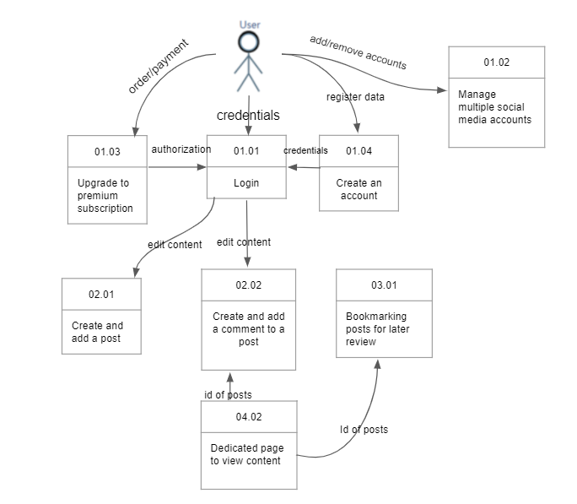

1. **DF-Out – Data Flow Out**

**Scope:**

* UC02.01 Ability to create and add a post.
* UC02.02 Create and add a comment to a post.
* UC01.03 Easily upgrade to premium subscription.

**Requirements:**

* Once save the most recent user search information while user update their search.
* User comment should stay on a page after post button is clicked, if the comment is posted.
* To upgrade premium subscription i.e from 01.03, user need to access Stream Feeder in their system’s web browser to sign up for premium.
* User will get authorization only when user order to upgrade premium subscription 01.03 and then only can get able to login user’s credentials 01.01.
* Once user authorized to use Premium (01.03), user should enter suitable payment information and then click on upgrade to his premium subscription.

            **Conditions to Apply:** After the respective join points.

